💊 PharmaEZ — Pharmacy & Healthcare E-Commerce
Phase | Project Design Phase II
Document | Data Flow Diagram & User Stories
Project Name | PharmaEZ — Pharmacy & Healthcare E-Commerce
Team ID | [TEAM-ID]
Date | 14 June 2026
Maximum Marks | 4 Marks

Data Flow Diagrams (DFD)

A Data Flow Diagram (DFD) visually represents how data enters, moves through, and leaves the PharmaEZ system. The diagrams below are presented at Level 0 (Context) and Level 1 (System internals).

DFD Level 0 — Context Diagram
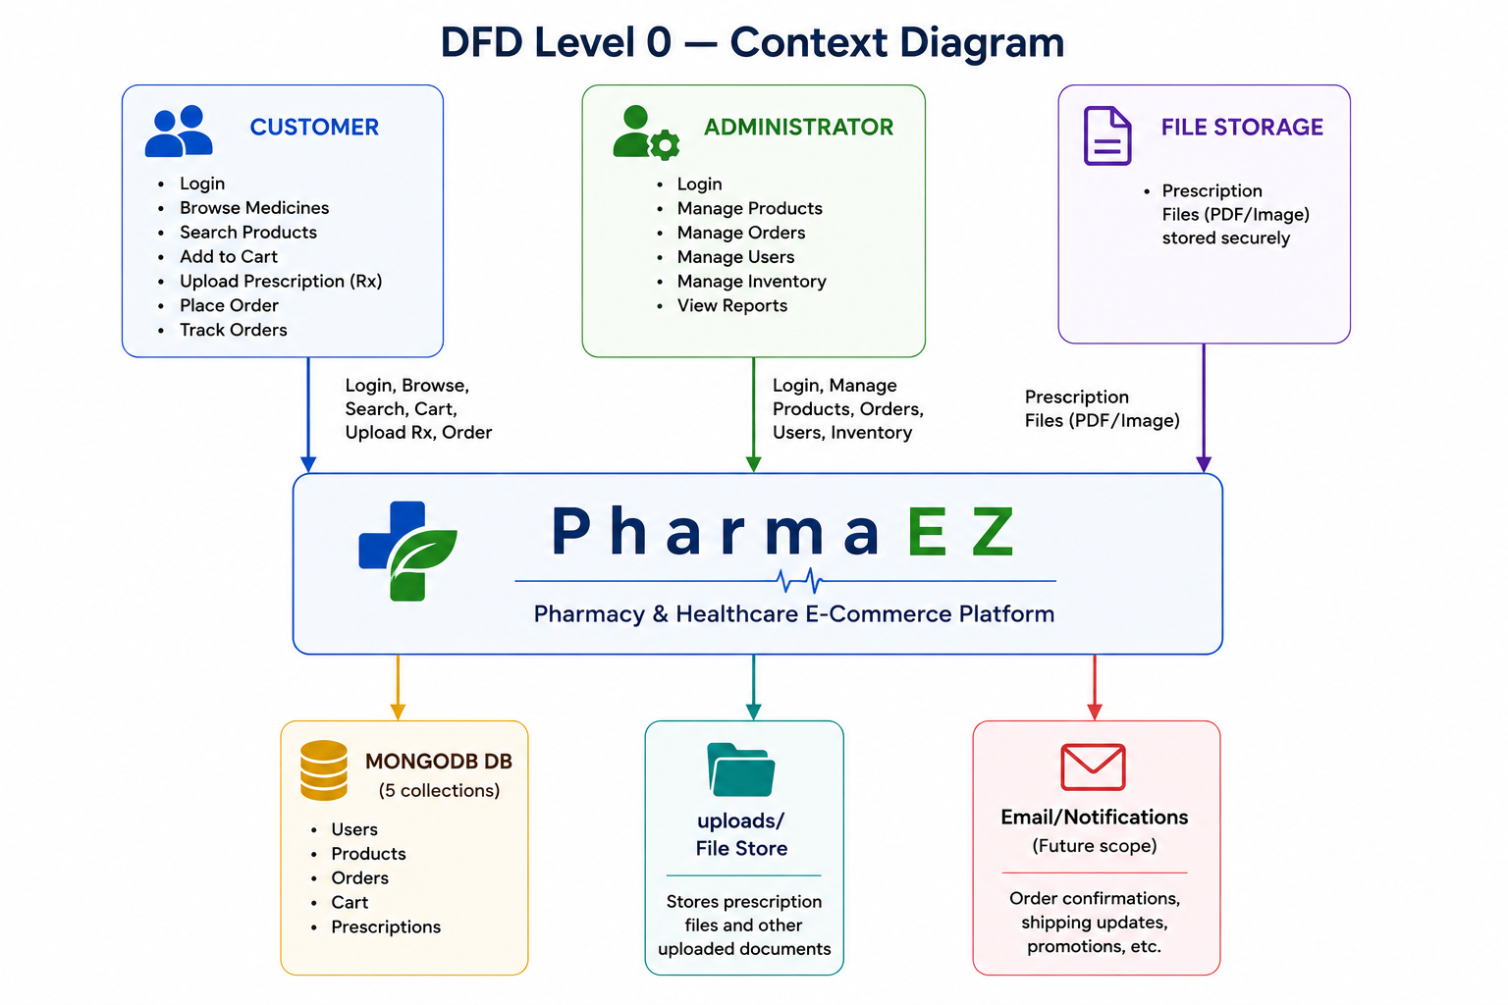

External Entities:
- Customer — Registers, browses, searches products, uploads prescriptions, manages cart, places and tracks orders, writes reviews
- Administrator / Pharmacist — Manages products, reviews prescriptions, updates order status, monitors inventory, views analytics
- File Storage (uploads/) — Receives prescription images/PDFs via Multer; serves them back for admin review

DFD Level 1 — PharmaEZ System Internals

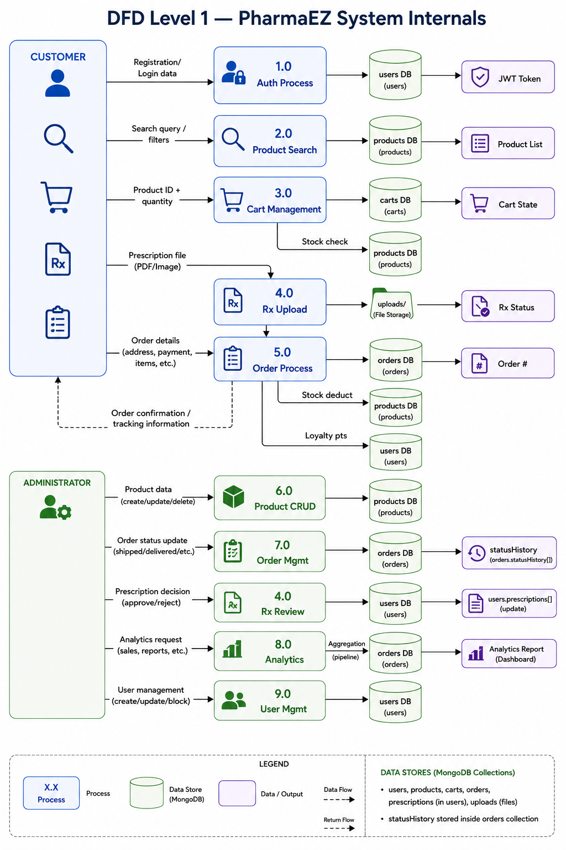

DFD Mermaid Code — Level 1

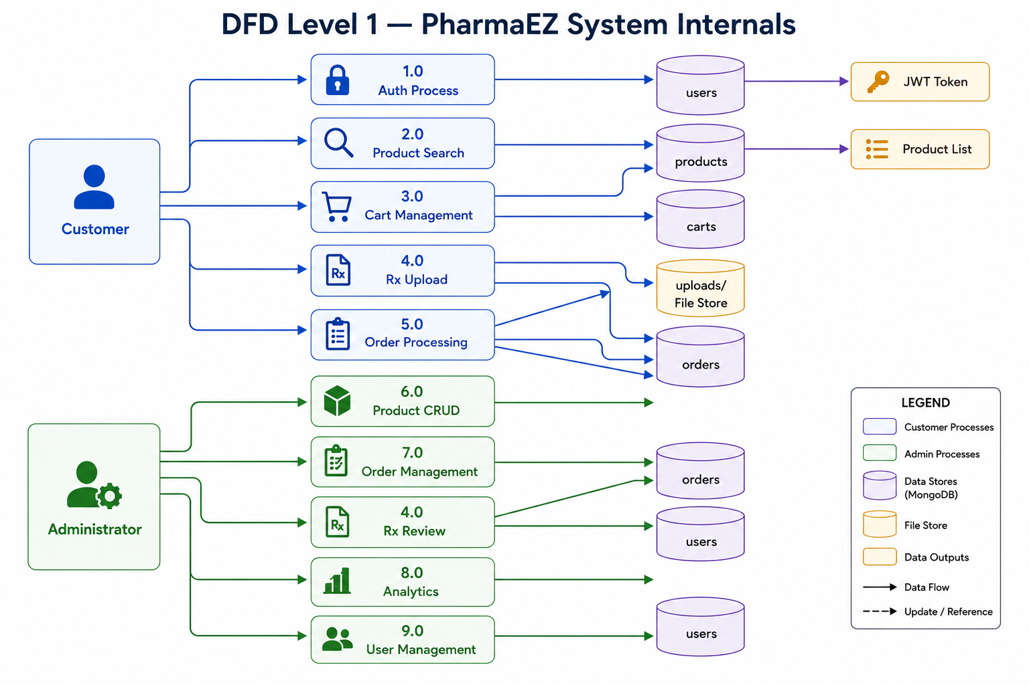

User Stories

The following user stories capture all functional requirements of PharmaEZ from the perspective of each user type.

User Type | Epic (FR) | USN | User Story / Task | Acceptance Criteria | Priority | Release
Customer | User Registration & Authentication | USN-1 | As a new user, I can register by entering my name, email, phone number, and password so that I can create a PharmaEZ account | Account created; JWT token received; redirected to homepage | High | Sprint 1
 |  | USN-2 | As a user, I can log in with my email and password and receive a JWT token for subsequent authenticated requests | Login successful; token stored in localStorage; cart fetched; redirected | High | Sprint 1
 |  | USN-3 | As a deactivated user, I receive a clear error message when trying to log in so that I understand my account status | Error: 'Account deactivated. Contact support.' shown on login | High | Sprint 1
Customer | Product Browse & Search | USN-4 | As a customer, I can search for a medicine by its brand name, generic name, or salt composition so that I can find the correct product | Products matching the keyword in name, genericName, or tags are returned | High | Sprint 1
 |  | USN-5 | As a customer, I can filter products by category, price range, and prescription requirement so that I can narrow down relevant results | Filtered results displayed with active filter tags; filters can be cleared individually | High | Sprint 1
 |  | USN-6 | As a customer, I can sort search results by price (low/high), top rated, or newest so that I can find the best option for my needs | Products re-ordered correctly; sort selection persists across page navigation | Medium | Sprint 1
 |  | USN-7 | As a customer, I can view paginated product results (12 per page) so that the page loads quickly and I can navigate through large catalogues | Pagination controls shown; correct products on each page; total count displayed | High | Sprint 1
Customer | Product Detail & Information | USN-8 | As a customer, I can view the salt composition, dosage form, strength, usage instructions, and side effects of a medicine so that I can make an informed purchase decision | All clinical fields displayed on the Detail tab; Usage and Reviews tabs accessible | High | Sprint 1
 |  | USN-9 | As a customer, I can see a clear 'Prescription Required (Rx)' notice on prescription medicines so that I know I need to upload a prescription before purchasing | Rx badge visible on product card and detail page; prescription upload link shown | High | Sprint 1
 |  | USN-10 | As a customer, I can add a product review (1–5 stars and comment) so that I can share my experience with other users | Review submitted; aggregate rating and numReviews updated; my review shown in list | Medium | Sprint 3
Customer | Prescription Management | USN-11 | As a patient with a prescription, I can upload my doctor's prescription (JPG/PNG/PDF, max 5MB) so that I can purchase Rx medicines legally | File uploaded; added to prescriptions[]; status shows 'pending'; success toast shown | High | Sprint 2
 |  | USN-12 | As a customer, I can view the status of my uploaded prescriptions (pending/approved/rejected) in my dashboard so that I know when my Rx order can proceed | Prescription list displays fileName, doctor, date, and colour-coded status badge | High | Sprint 2
Customer | Shopping Cart | USN-13 | As a customer, I can add products to my cart and have the cart persist across browser sessions so that I don't lose my selections | Item added to MongoDB cart; cart badge count updates; item visible on cart page after refresh | High | Sprint 1
 |  | USN-14 | As a customer, I can increase/decrease item quantities in my cart with real-time stock validation so that I cannot order more than is available | Quantity bounded by stock; error toast if stock limit reached; subtotal updates in real-time | High | Sprint 1
 |  | USN-15 | As a customer, I can see a free shipping progress bar showing how much more I need to spend to get free delivery so that I can decide whether to add more items | Bar fills proportionally to ₹499 threshold; 'FREE' shown when order >= ₹499 | Medium | Sprint 2
Customer | Checkout | USN-16 | As a customer, I can select from my saved delivery addresses or enter a new one during checkout so that the order is delivered to the correct location | Address list shown if saved; new address form available; selection persists to Step 3 | High | Sprint 2
 |  | USN-17 | As a customer, I can select my payment method (COD, UPI, Card, Net Banking) during checkout so that I can pay in the way that suits me | Payment method selected; shown in order review Step 3 and on order confirmation | High | Sprint 2
 |  | USN-18 | As a customer, I can review my complete order summary before confirming so that I can verify all details before placing the order | Step 3 shows items, address, payment method, and full price breakdown (subtotal, shipping, GST, total) | High | Sprint 2
Customer | Order Management & Tracking | USN-19 | As a customer, I can view my unique order number (e.g. PEZ7829430001) on the confirmation page so that I can reference it for queries | Order confirmation page displays orderNumber, estimated delivery, payment details | High | Sprint 2
 |  | USN-20 | As a customer, I can track my order status through a 5-step visual tracker so that I know where my order is at all times | Progress tracker shows current step highlighted; status matches backend orderStatus | High | Sprint 2
 |  | USN-21 | As a customer, I can cancel an order that has not yet been shipped so that I can change my mind before dispatch | Cancel button visible; order status → 'cancelled'; stock restored; confirmation shown | Medium | Sprint 2
 |  | USN-22 | As a customer, I earn 1 loyalty point per ₹10 spent after delivery so that I am rewarded for my purchases | loyaltyPoints in User document incremented on order delivery; balance shown in dashboard | Medium | Sprint 3
Customer | Wishlist | USN-23 | As a customer, I can add and remove products from my wishlist so that I can save items for later purchase | Heart icon toggles; wishlist[] array in user document updated; Wishlist page reflects change | Medium | Sprint 3
Administrator | Product Management (CRUD) | USN-24 | As an admin, I can create a new healthcare product with all pharmacy-specific fields so that it appears in the catalogue for customers to purchase | Product created with saltComposition, dosageForm, strength, sideEffects, usageInstructions; visible in product listing | High | Sprint 1
 |  | USN-25 | As an admin, I can search and filter the product list so that I can quickly find a product to edit or delete | Search by keyword returns matching products; pagination works on filtered results | High | Sprint 1
 |  | USN-26 | As an admin, I can toggle the 'isFeatured' flag on a product so that it appears in the homepage Featured Products section | Product with isFeatured=true appears in GET /products/featured response; shown on homepage | Medium | Sprint 2
 |  | USN-27 | As an admin, I can delete a product with a confirmation prompt so that I can remove discontinued items | Product removed from database; no longer appears in search or catalogue | High | Sprint 2
Administrator | Order Management | USN-28 | As an admin, I can view all orders filtered by status so that I can manage fulfilment queues efficiently | Filter pills work; correct orders shown per status; total count displayed | High | Sprint 2
 |  | USN-29 | As an admin, I can update an order's status and have every change logged in the statusHistory[] audit trail so that there is a complete record of order handling | Status updated in DB; statusHistory[] receives {status, timestamp, note}; badge updates in table | High | Sprint 2
Administrator | Prescription Review | USN-30 | As a pharmacist/admin, I can view all uploaded prescriptions and approve or reject them so that only valid prescriptions are fulfilled | Prescription status updated to 'approved'/'rejected'; linked order prescriptionStatus updated | High | Sprint 2
 |  | USN-31 | As an admin, I can view the prescription image inline or open the PDF in a new tab so that I can review it without leaving the admin panel | Image shown in side panel; PDF link opens in new tab; patient and doctor info displayed | High | Sprint 2
Administrator | User Management | USN-32 | As an admin, I can deactivate a user account so that fraudulent or policy-violating accounts cannot log in | user.isActive set to false; login attempt returns 'Account deactivated' error | High | Sprint 3
Administrator | Inventory Management | USN-33 | As an admin, I can view low-stock alerts for products with ≤10 units remaining so that I can restock before stockouts occur | Low-stock table on dashboard and inventory page shows correct products; stock count colour-coded amber | High | Sprint 3
 |  | USN-34 | As an admin, I can view a 7-day revenue bar chart and KPI summary cards on the dashboard so that I can monitor business performance | Revenue aggregation query returns daily data; chart renders correctly; KPIs show correct totals | High | Sprint 3

